Assignment 12

210010033

Part 1:

1. SSID "30 Munroe St" and "linksys12" are the ones issuing most of the beacon frames in this trace.
2. Beacon Interval is 0.102400 [Seconds] for "30 Munroe St"and Beacon Interval is 0.102400 [Seconds] for "linksys12"
3. Source address: CiscoLinksys_f7:1d:51 (00:16:b6:f7:1d:51)
4. Destination address: Broadcast (ff:ff:ff:ff:ff:ff)
5. BSS Id: CiscoLinksys_f7:1d:51 (00:16:b6:f7:1d:51)
6. 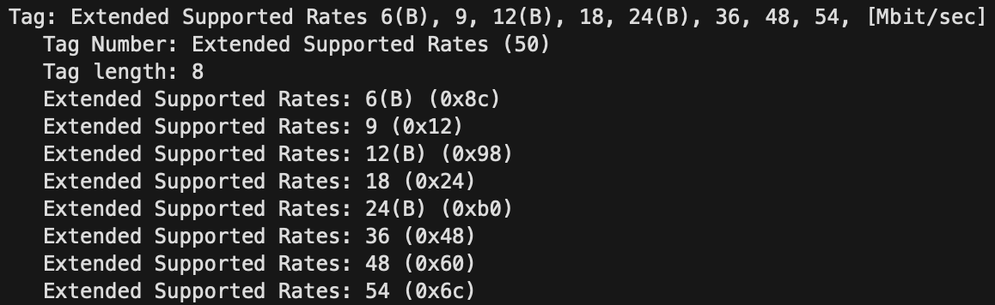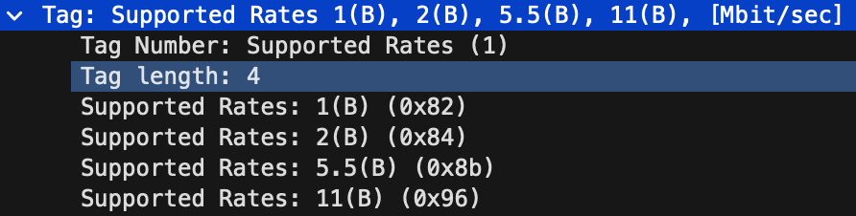The supported rates are as follows:  
     
     
   The extended rates are as follows(in Mbps):

Part 2:

1. The respective address are as follows:  
   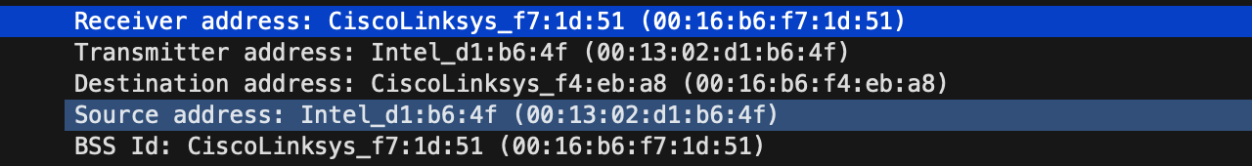  
     
   The TCP SYN message is contained in the frame sent at t=24.811093 seconds.(Frame No. 474)  
     
   The MAC address corresponding to the wireless host is 00:13:02:d1:b6:4f.  
   The MAC address corresponding to the Access point is 00:16:b6:f7:1d:51  
   The MAC address corresponding to the First hop router is 00:16:b6:f7:1d:51  
     
   Source IP:192.168.1.109   
   Destination IP: 128.119.245.12
2. Receiver address: 91:2a:b0:49:b6:4f   
   Transmitter address: CiscoLinksys_f7:1d:51 (00:16:b6:f7:1d:51)  
   BSS Id: CiscoLinksys_f7:1d:51 (00:16:b6:f7:1d:51)  
     
   The TCP SYNACK message is received at t=24.827751 seconds into the trace.(Frame No. 476)  
     
   The MAC address corresponding to the wireless host is 00:16:b6:f7:1d:51.  
   The MAC address corresponding to the Access point is 91:2a:b0:49:b6:4f   
   The MAC address corresponding to the BSS is 00:16:b6:f7:1d:51   
     
   Server IP: 128.119.245.12

Part 3:

1. Screenshot 2024-04-06 at 6.08.45 PM  
     
   The two actions taken include DHCP release(frame 1733) and Deauthentication (frame 1735)  
     
   The action which was expected here was a diassociation message.
2. 15 Authentication messages were sent.
3. Yes, the host wants authentication to be open.
4. No, I don’t see reply AUTHENTICATION from the linksys_ses_24086 AP in the trace.
5. AUTHENTICATION frame from the host to 30 Munroe St. AP at: 63.168087s (Frame No. 2156)  
   Reply AUTHENTICATION sent from that AP to the host reply at: 63.169071s (Frame No. 2158)  
   AUTHENTICATION frame retransmitted from host to 30 Munroe St. AP at: 63.169707s (Frame No. 2160)  
   Reply AUTHENTICATION sent from that AP to retransmitted host reply at: 63.170692s(Frame No. 2164)
6. 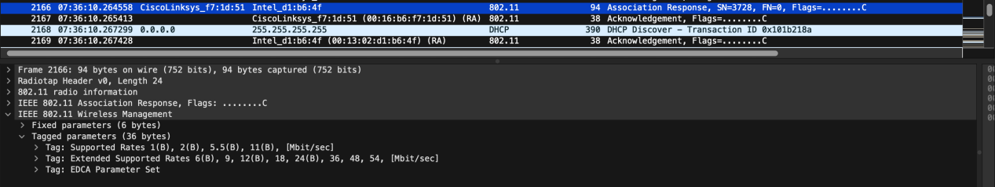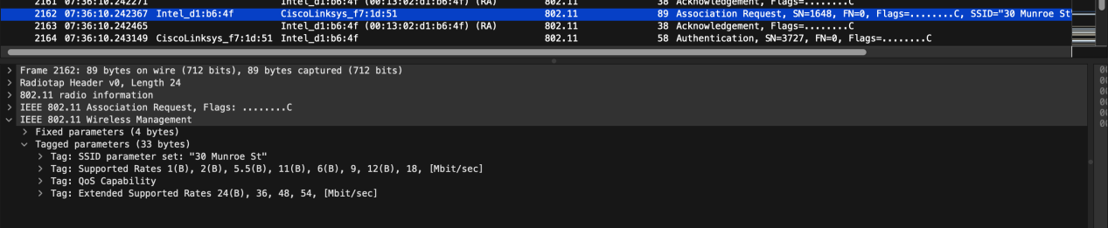  
     
   Frame: 2162 at time = 7:36:10.24 contains the association request from the host  
     
     
   Frame: 2166 at time = 7:36:10.2 contains the association response to the host.
7. Rates supported by host include: 1(B), 2(B), 5.5(B), 11(B), 6(B), 9, 12(B), 18, 24(B), 36, 48, 54, [Mbit/sec]  
     
   Rates supported by the AP include: 1(B), 2(B), 5.5(B), 11(B), 6(B), 9, 12(B), 18, 24(B), 36, 48, 54, [Mbit/sec]

Part 4:

1. 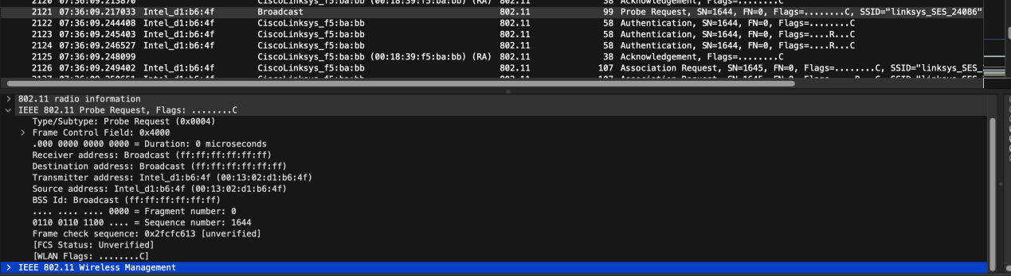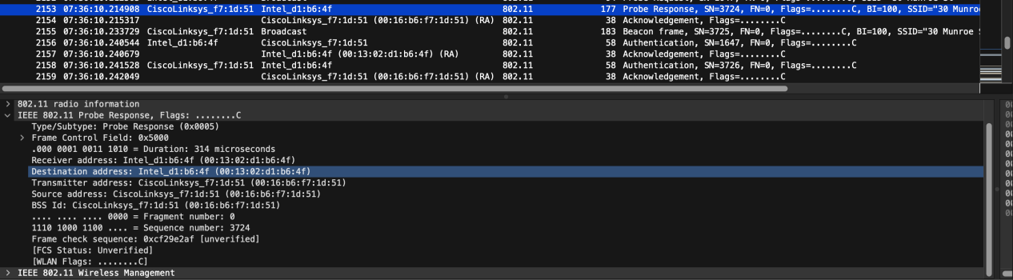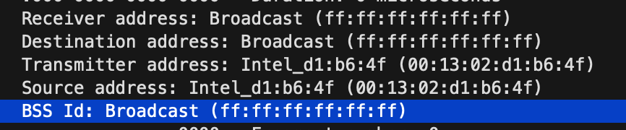  
   Respective addresses are   
     
     
   Frame: 2121 contains the PROBE REQUEST  
     
     
   Frame: 2153 contains the PROBE RESPONSE  
     
   Probe Request Frames are sent by a device when it wants to discover nearby Wi-Fi networks.This frame is used by devices to search for available networks. When we turn on the Wi-Fi or manually search for networks on the device, it sends out Probe Request frames to find nearby access points.   
     
   Probe Response Frames: An access point (AP) or Wi-Fi router sends a Probe Response frame in response to a Probe Request from a client device. The Probe Response contains information about the access point, including its SSID (network name), supported Wi-Fi standards, security settings, and other network parameters. This information helps the client device decide which network to connect to.